#### **DRESUME**

**by**

**Yash Gupta (2200320140198)**

#### Under the guidance of

##### Mr. Asheesh Pandey

##### (Assistant Professor)(Sr. Scale)

**Department of Computer Applications**

|  |
| --- |
|  |

**ABES Engineering College**

**19th Km Stone, NH-09, Ghaziabad (U.P)**

**July, 2024**

**DRESUME**

**by**

**Yash Gupta (2200320140198)**

**Submitted to the Department of Computer Applications**

**in partial fulfillment of the requirements**

**for the degree of**

**Master of Computer Application**

#### Under the guidance of

##### Mr. Asheesh Pandey

##### (Assistant Professor) (Sr.Scale)

**Department of Computer Applications**

|  |
| --- |
|  |

**ABES Engineering College**

**19th Km Stone, NH-09, Ghaziabad (U.P)**

**July, 2024**

**DECLARATION**

I hereby declare that the work being presented in this report entitled “**dResume**” is an authentic record of my work carried out under the supervision of “**Mr. Asheesh Pandey**”

The matter embodied in this report has not been submitted by me for the award of any other degree.

**Date: Signature of students(s)**

**Yash Gupta**

**Dept.: Computer Applications**

This is to certify that the above statement made by the candidate is correct to the best of my knowledge.

**Signature of HOD Signature of Supervisor**

**Prof. (Dr.) Devendra Kumar Mr. Asheesh Pandey**

**HOD-MCA Assistant Professor**

**(Sr. Scale)**

**Dept.:-Computer Applications**

**Date:**

**CERTIFICATE**

This is to certify that Project Report entitled **“dResume”** which is submitted by **Yash Gupta** in partial fulfillment of the requirement for the award of degree **Master of Computer Application** in Department of Computer Applications of **Dr. A.P.J. Abdul Kalam Technical University,** is a record of the candidate’s own work carried out by him/them under my supervision.

The matter embodied in this Major Project Report is original and has not been submitted for the award of any other degree.

The plagiarism percentage evaluated for the content presented is

**Supervisor Signature**

**Mr. Asheesh Pandey**

**Assistant Professor**

**(Sr. Scale)**

**Date:**

## ACKNOWLEDGEMENT

Introducing the report on the MCA project finished during MCA Final Year fills me with incredible happiness. I owe an exceptional obligation of appreciation to **Mr. Asheesh Pandey (Assistant Professor)** **Department of Computer Applications, ABESEC, Ghaziabad** for his/her constant support and guidance throughout the course of our work. His /Her sincerity, thoroughness, and perseverance have been a constant source of inspiration for me. It is just his perceptive endeavors that our undertakings have come around.

I also take the opportunity to recognize the contribution of **Prof. (Dr.) Devendra Kumar Head, Department of Computer Applications, ABESEC, Ghaziabad** for his support and assistance during the development of the project.

I also don't want to miss the opportunity to thank the entire department's faculty members for their helpful support and cooperation during the project's development. Last but not least, we want to thank our friends for their help in getting the project done.

**Signature of Student(s)**

**Yash Gupta**

**2200320140198**

## ABSTRACT

The current system creates resumes manually either using Word or Google doc, so there are some issues with the current system. The existing system suffered from a number of shortcomings. Since the entire system had to be maintained, the process of storing, maintaining and retrieving information was very tedious and time-consuming. The records were never in a systematic order, there used to be a lot of difficulty in assigning any particular transaction to a particular context. If any information was to be found, it was required to go through various registers, the documents would never exist. something like report generation There would always be wasted time entering records and retrieving records Another problem was that it was very difficult to find errors in entering records Once the records were inserted it was very difficult to update those records.

**TABLE OF CONTENT**

|  |  |  |  |  |
| --- | --- | --- | --- | --- |
| **Sr.**  **No.** | **Content** | | | **Page No.** |
| 1. | Introduction | | | 1 |
|  | 1.1 | Objective | | 2 |
|  | 1.2 | Problem Statement | | 3 |
|  | 1.3 | Problem Definition | | 4 |
| 2. | Literature Review | | |  |
| 3. | Feasibility Study | | | 5 |
|  | 3.1 | | Technical | 5 |
|  | 3.2 | | Operational | 5 |
|  | 3.3 | | Economic | 5 |
|  | 3.4 | | Cost Estimation | 6 |
| 4 | Requirements | | | 7 |
|  | 4.1 | Technologies Used | | 8 |
|  | 4.2 | Functional Requirements | | 10 |
|  | 4.3 | Non-Functional Requirements | | 11 |
| 5 | Design | | | 12 |
|  | 5.1 | Model View Controller(MVC) Diagram | | 12 |
|  | 5.2 | ER-Diagram | | 13 |
|  | 5.3 | Data Flow Diagram | | 14-15 |
|  | 5.4 | Use Case | | 16 |
|  | 5.5 | Class Diagram | | 17 |
|  | 5.6 | Deployment Diagram | | 18 |
| 6 | GUI/ Coding | | | 19 |
|  | TimeLine | | | 49 |
|  | Gantt Chart | | | 50 |
| 7 | Conclusion | | | 51 |
|  | 7.1 Future Scope | | | 52 |
| 8 | References | | | 53 |
|  | Appendices (Plagiarism Report) | | |  |

## LIST OF FIGURES

|  |  |  |
| --- | --- | --- |
| **S. No.** | **Topic** | **Page No.** |
| Figure-1 | MVC Diagram | 12 |
| Figure-2 | ER-Diagram | 13 |
| Figure-3 | 0 level DFD | 14 |
| Figure-4 | 1st level DFD | 15 |
| Figure-4 | Use Case Diagram | 16 |
| Figure-5 | Class Diagram | 17 |
| Figure-6 | Deployment Diagram | 18 |

**LIST OF TABLES**

|  |  |  |
| --- | --- | --- |
| **S. No.** | **Topics** | **Page No.** |
| Table-1 | Timeline of Project | 49 |
| Table -2 | Gantt Chart | 50 |

# **CHAPTER 1**

### 1.1 **INTRODUCTION**

A resume is the first meeting between you and a potential employer, more often than ever. So how do you want to be remembered? Wrinkled and messy. Neat and structured. Long and boring. Accurate and interesting. Companies do not have time to interview every applicant who is interested in the job. If they did, there would be no company to work for. They use a process of elimination. That's right - he continues. When a job seeker wants to apply for a job online, they generally need to attach their resume to an email. The online resume builder system provides users with popular resume formats and a better way to showcase their resumes to employers. A job seeker does not need to attach a resume to every email, just provide the URL of your resume and the employer can view the resume online by clicking on the link and also download it.

### 

### 1.2 **OBJECTIVE**

The Objectives of Online Resume Builder are -

**Simplify the resume creation process:** Provide a user-friendly interface to create a professional-looking resume in a short amount of time.

**Offer customization options:** Allow users to tailor their resume to specific job openings or industries by providing a range of templates, formatting options, and content suggestions.

**Improve job search efficiency:** Help users create a strong, attention-grabbing resume that increases their chances of getting noticed by potential employers and recruiters.

**Enhance job search visibility:** Assist users in creating a resume that is optimized for applicant tracking systems (ATS) and search engines, making it more likely to appear in search results.

**Save time and effort:** Automate the resume creation process, allowing users to focus on other aspects of their job search, such as networking and interviewing.

**Improve user experience:** Make the resume creation process enjoyable and engaging, with features such as drag-and-drop interfaces, real-time feedback, and easy editing capabilities.

### 1.3 PROBLEM STATEMENT

The current system creates resumes manually using either Word or Google doc, so there are some issues with the current system. The existing system suffered from a number of shortcomings. Since the entire system had to be maintained, the process of storing, maintaining and retrieving information was very tedious and time-consuming. The records were never in a systematic order, there used to be a lot of difficulty in assigning any particular transaction to a particular context. If any information was to be found, it was required to go through various registers, the documents would never exist. something like generating reports There would always be wasted time entering records and retrieving records Another problem was that it was very difficult to find errors in entering records Once the records were entered it was very difficult to update those records.

### Aims & Objectives:

The purpose of this online resume builder is to help users create a professional resume for themselves. Candidates don't need to invest extra time in planning and creating a polished resume. They can immediately enter their information in the pop-up box and a resume with a nice layout will be generated for them.

### 1.4 PROBLEM DEFINITION

* Project is related to Online Resume Building.
* This project maintains 3 types of users.
* Administrator User
* Users(Customers)

* Facilities provided by this projects are as follows
  + Details of customers are recorded.
  + Updating of data is easy.
  + Flow of information is fast and easy.
  + Customers can login to their accounts and view &update their data.
  + Notifications about resume views & downloads

### 

### 

### **CHAPTER 2**

### LITERATURE REVIEW

### 

### A. Manual Creation of Resume

### Long Back resumes were created manually by using MS Word and the format at that time was quite different. These are the fields that applicants used to mention in their resumes, in personal information applicants used to write their name, address and phone number. Applicants also used to mention their personal opinion in their resume. That time applicants used to mention their both early and recent education details. Applicants used to create either too short or too long resumes because at that time there were no standards set for ideal length of resumes.

### 

### B. Inference Drawn From Conclusion

### Some inferences are drawn from literature review and research regarding what should be the length of a resume? What information should be included in a resume? What information should be avoided while writing a resume? Ideally in personal information name, address, phone number, email address should be included and height, weight, religion, birth date, marital status should be avoided. Resumes of one page length are preferred more over resumes of two page length.

### 

### 

### **CHAPTER** 3

### FEASIBILITY STUDY

#### **3.1 TECHNICAL FEASIBILITY**

Technical feasibility is concerned with the availability of hardware and software required for the development of the system, to see compatibility and maturity of the technology proposed to be used and to see the availability of the required technical manpower to develop the system. After the study we came to conclusion that we proceed further with the tools and development environment chosen by us. This was important in our case as we were working on two various phases of the department that will need to be integrated in future to make an extended system.

#### **3.2 OPERATIONAL FEASIBILITY**

Operational feasibility is all about problems that may arise during operations. There are two aspects related with this issue:

* + What is the probability that the solution developed may not put to use or may not work?
  + What is the inclination of the management and end users towards the solution? Though, there is very least possibility of management being averse to the solution, there is a significant probability that the end users may not be interested in using the solution due to lack of training, insight etc.

#### **3.3 ECONOMIC FEASIBILITY**

It is the measure of cost effectiveness of the project. The economic feasibility is nothing but judging whether the possible benefit of solving the problems is worthwhile of not. At the feasibility study level, it is impossible to estimate the cost because member's requirements and alternative solutions have not been identified at this stage. However, when the specific requirements and solutions have been identified, the analyst weighs the cost and benefits of all solutions, this is called "cost benefit analysis.

### **COST ESTIMATION**

Software cost comprises a small percentage of overall computer- based system cost. There are a number of factors, which are considered, that can affect the ultimate cost of the software such as - human, technical, Hardware and Software availability etc. The main point that was considered during the cost estimation of project was its sizing. In spite of complete software sizing, function point and approximate lines of code were also used to "size" each element of the Software and their costing. The cost estimation done by me for Project also depend upon the baseline metrics collected from past projects and these were used in conjunction with estimation variables to develop cost and effort projections.

We have basically estimated this project mainly on two bases -

1)Effort Estimation - This refers to the total man-hours required for the development of the project. It even includes the time required for doing documentation and user manual.

2)Hardware Required Estimation - This includes the cost of the PCs and the hardware cost required for development of this project.

#### CHAPTER 4

#### REQUIREMENT ANALYSIS

**User Registration and Authentication:**

* Users should be able to create accounts with a valid Username and password.
* Secure authentication mechanisms should be implemented to protect user accounts.

**Portfolio:**

* Users can add and show their Reviews..

**Blog**:

* Users can create and edit their blog posts.

**Contact:**

* Users can contact the person by filling out the contact form.

**Key Skills:**

* User can showcase their key skills and edit them.

**Coding Skills:**

* User can show and edit their coding skills.

**Performance:**

* A website should serve a specified number of concurrent users without degrading performance.

**Security:**

* User Details must be stored Safely.

**Usability:**

* The website should have an intuitive and responsive design for a positive user experience.

#### **4.1 TECHNOLOGIES USED**

* + **HTML:**

The Hyper Text Mark-up Language or HTML is the standard mark-up language for documents designed to be displayed in a web browser. It can be assisted by technologies such as Cascading Style Sheets and scripting languages such as JavaScript.

#### CSS:

Cascading Style Sheets is a style sheet language used for describing the presentation of a document written in a mark-up language such as HTML or XML. CSS is a cornerstone technology of the World Wide Web, alongside HTML and JavaScript.

* + **Django:**

Django is a high-level Python web framework that encourages rapid development and clean, pragmatic design. Built by experienced developers, it takes care of much of the hassle of web development, so you can focus on writing your app without needing to reinvent the wheel. It’s free and open source.

* + **Python:**

Python is a high-level, general-purpose programming language. Its design philosophy emphasizes code readability with the use of significant indentation. Python is dynamically typed and garbage-collected. It supports multiple programming paradigms, including structured, object-oriented and functional programming.

* + **Text Editor or VS-code:**

A text editor is a type of computer program that edits plain text. Such programs are sometimes known as "notepad" software.

#### **4.2 FUNCTIONAL REQUIREMENTS**

**User Registration and Authentication:**

* Users should be able to create accounts with a valid Username and password.
* Secure authentication mechanisms should be implemented to protect user accounts.

**Portfolio:**

* Users can add and view their reviews.

**Blog**:

* Users can create and edit their blog posts.

**Contact:**

* Users can contact the person by filling out the contact form.

**Key Skills:**

* User can showcase their key skills and edit them.

**Coding Skills:**

* User can show and edit their coding skills.

#### **4.3 NON – FUNCTIONAL REQUIREMENTS**

**Performance:**

* A website should serve a specified number of concurrent users without degrading performance.

**Security:**

* User data must be stored securely.

**Usability:**

* Websites should have an intuitive and responsive design for a positive user experience.

**CHAPTER 5**

**DESIGN**

**MVC (Model View Controller Flow) Diagram**

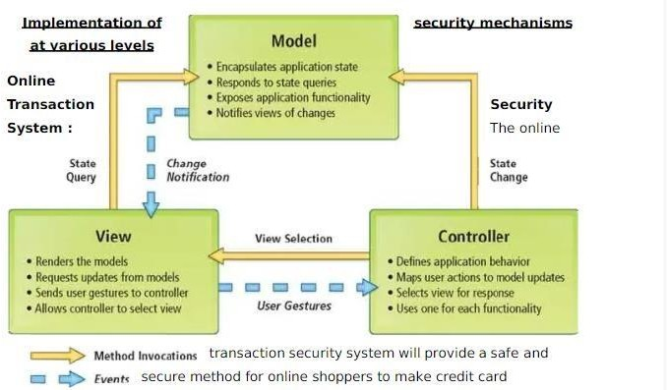

### ER-DIAGRAM

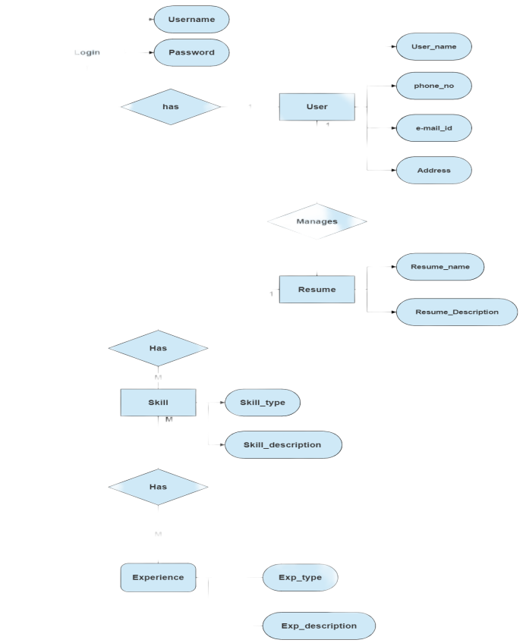

**Zero Level DFD**

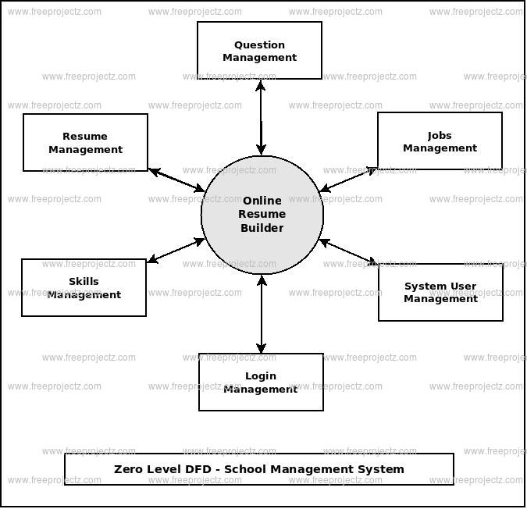

**First Level DFD**

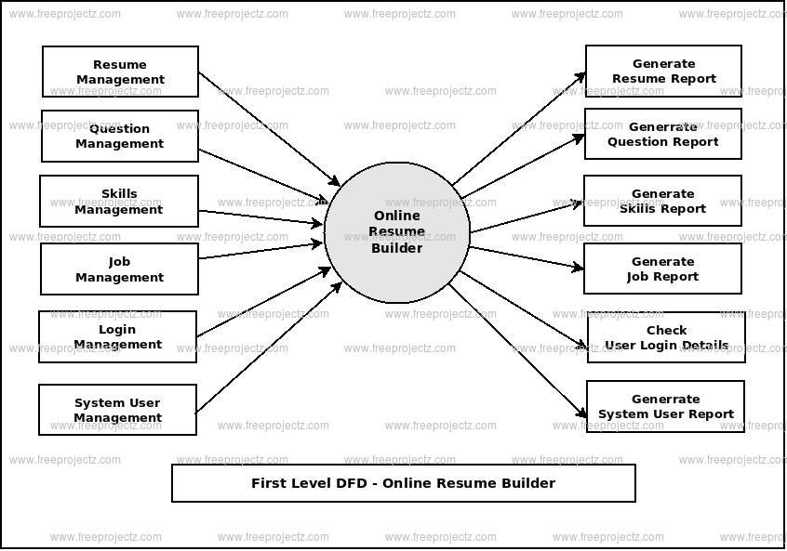

### USE CASE DIAGRAM

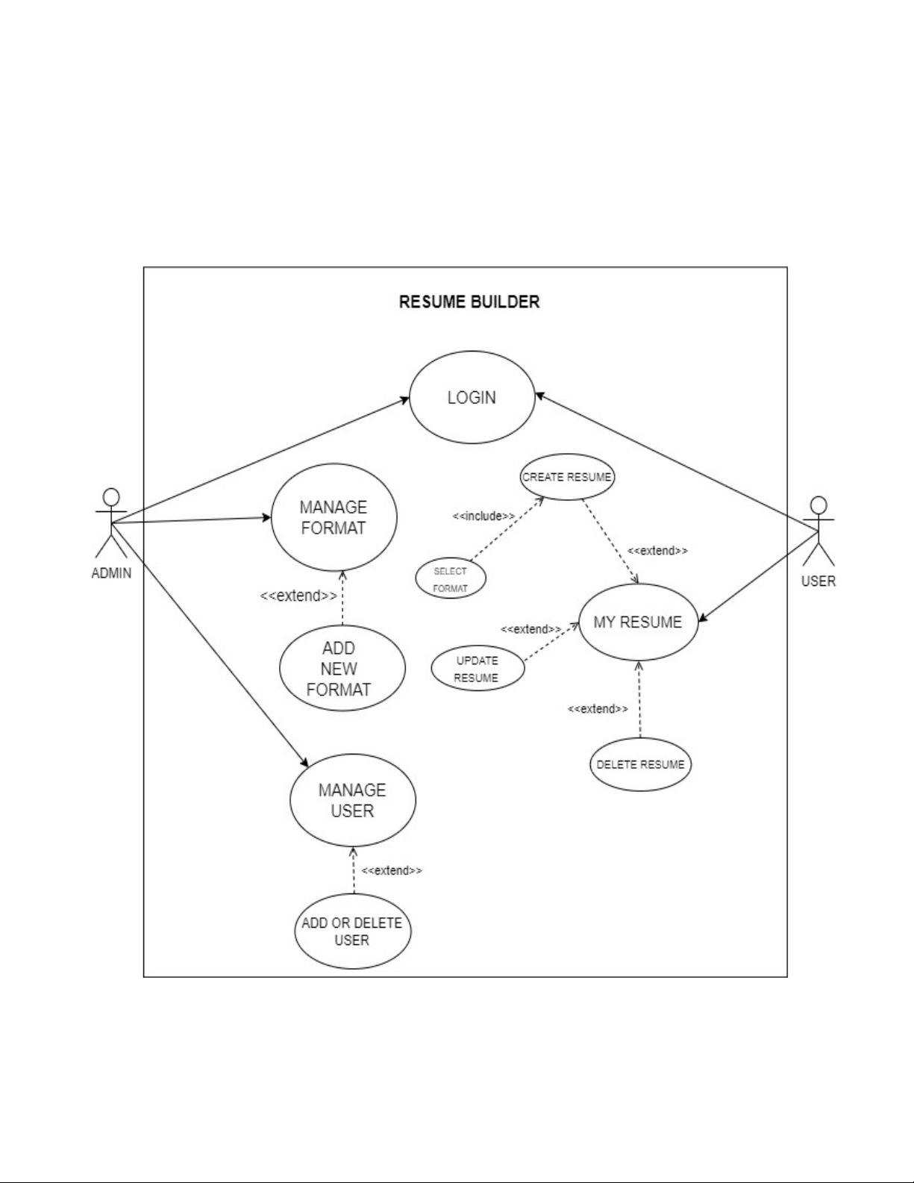

**CLASS DIAGRAM**

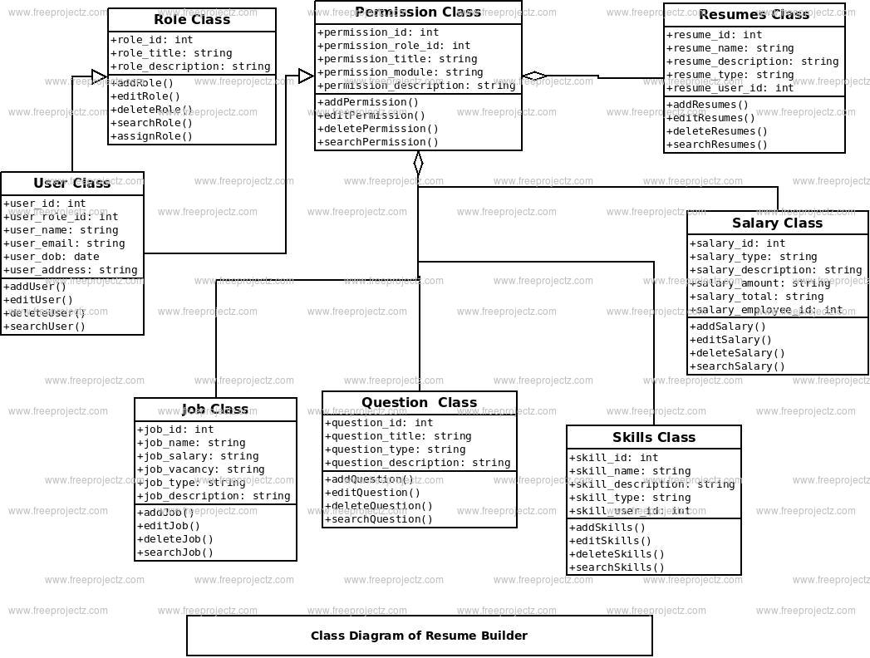

### DEPLOYMENT DIAGRAM

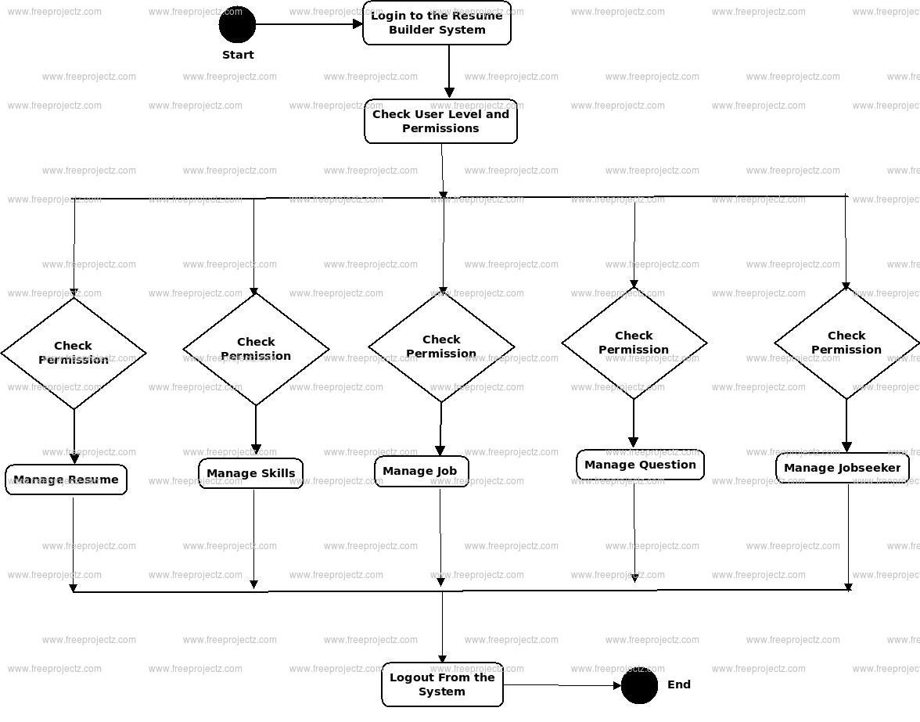

#### CHAPTER 6

#### GRAPHIC USER INTERFACE(GUI)

**Modules Screenshot**

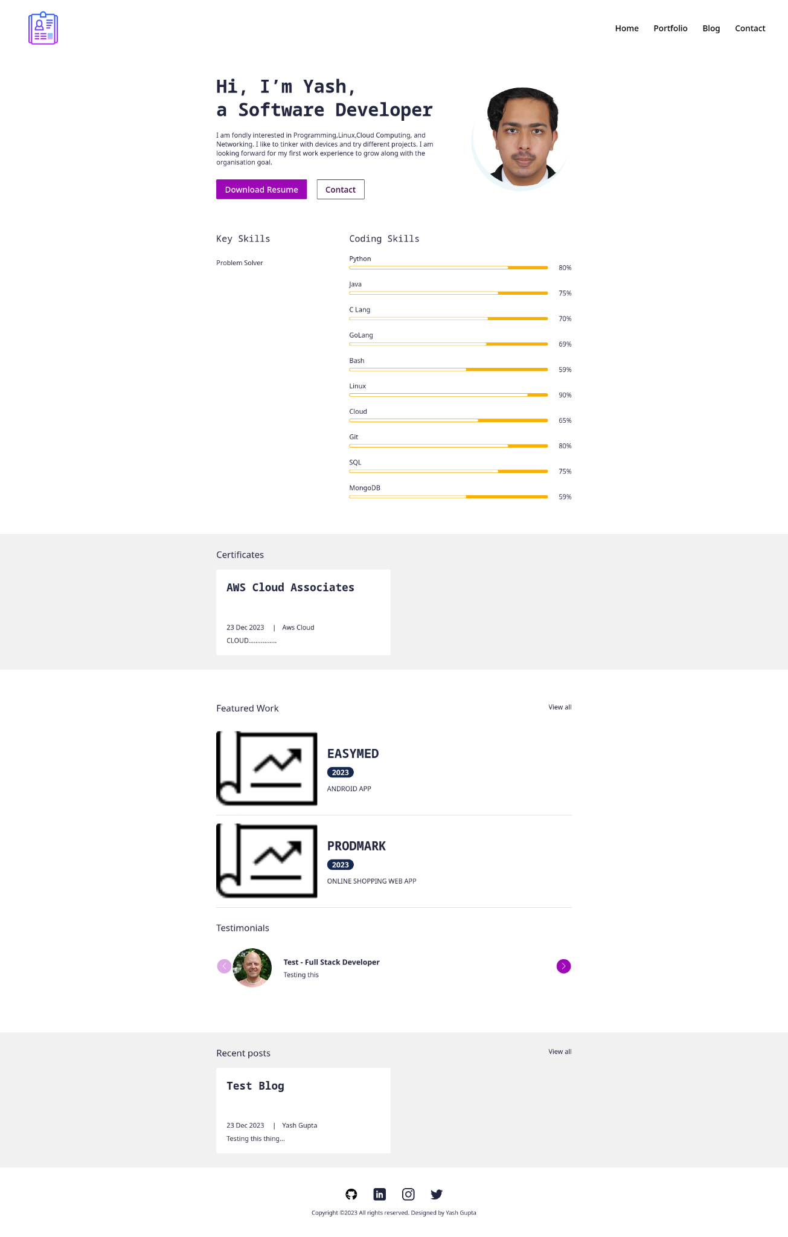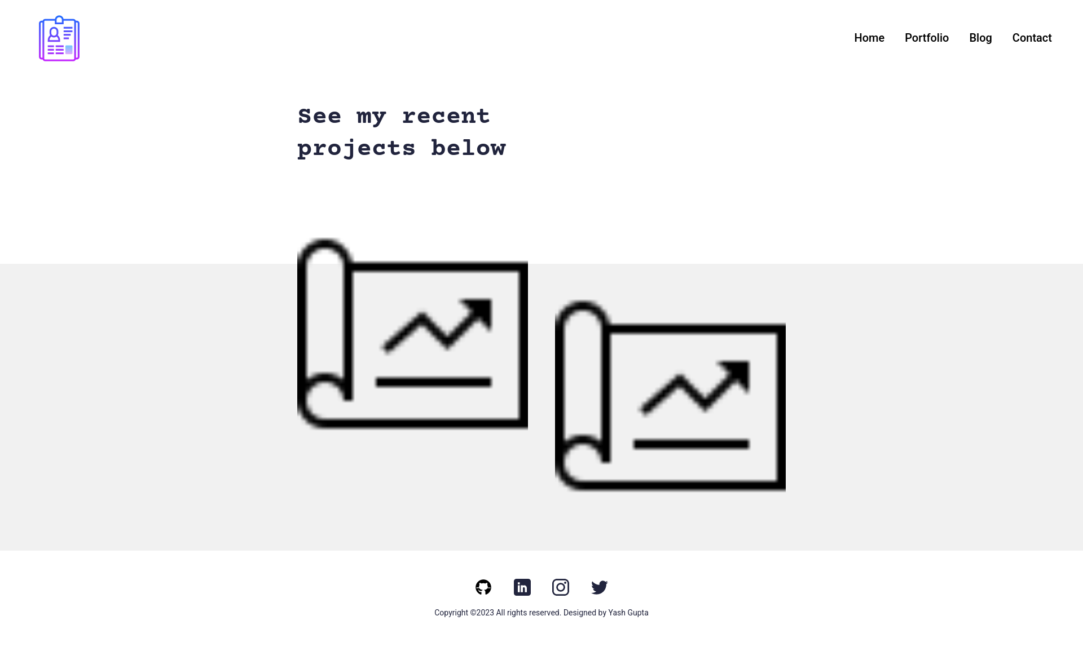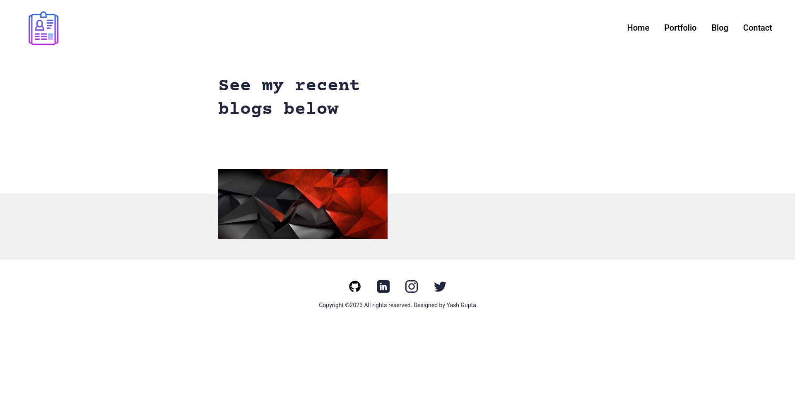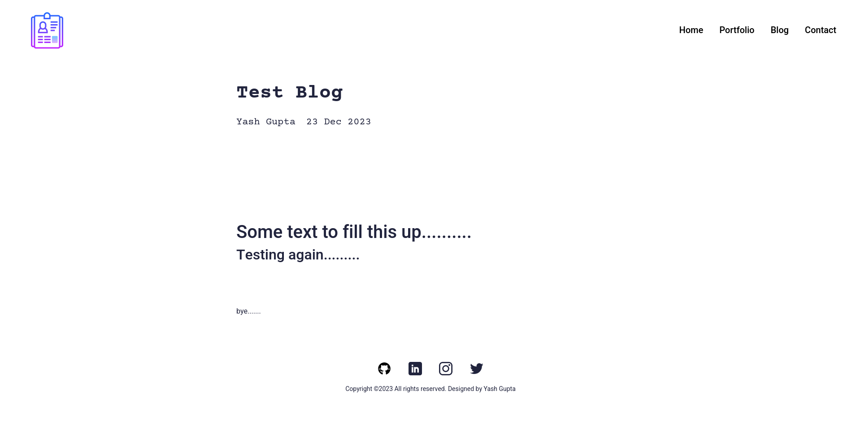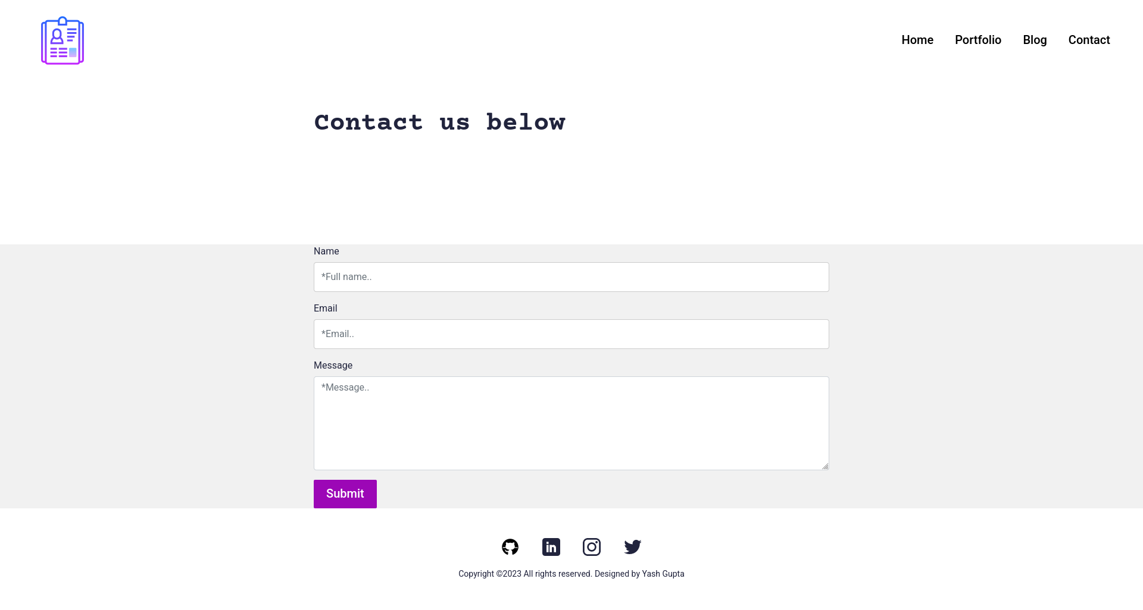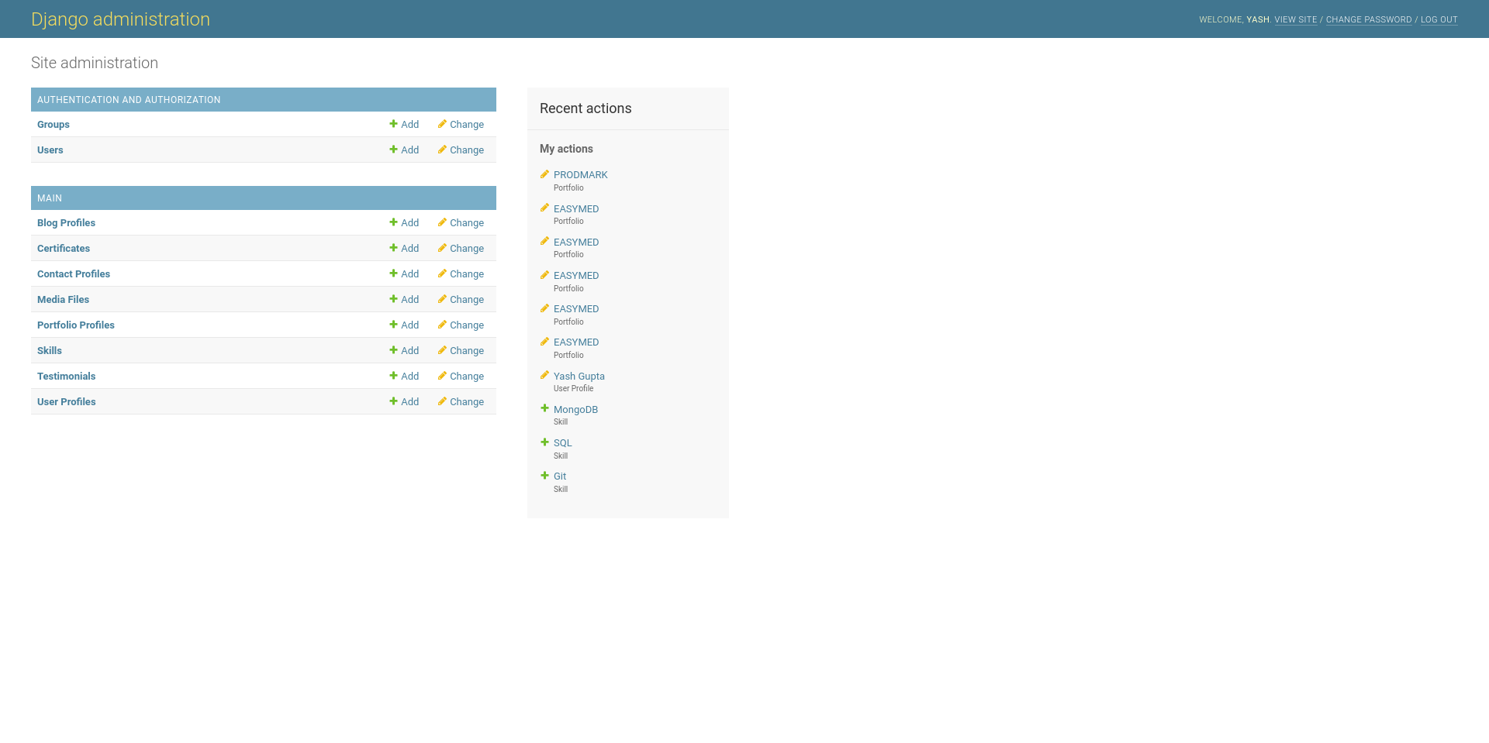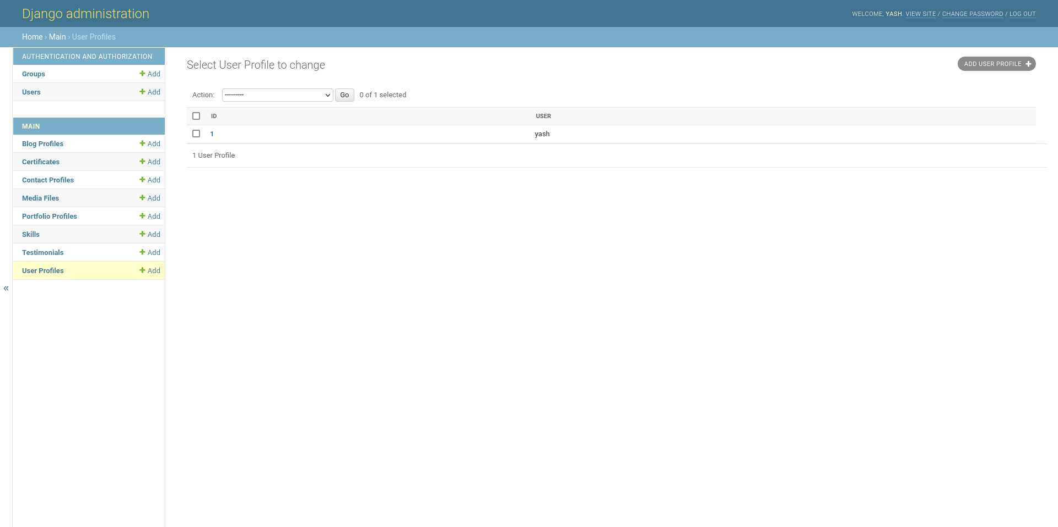

#### CODING PHASE

#### **HTML**

#### Base.html

#### {% load static %}

#### <!doctype html>

#### <html lang="en">

#### <head>

#### <meta charset="utf-8">

#### <meta name="viewport" content="width=device-width, initial-scale=1">

#### <title>{% block title %}{%endblock %}</title>

#### <meta name="author" content="Did Coding Limited & James Granger Design">

#### <link rel="canonical" href="{{request.path}}"/>

#### <link rel="home" href="{% url 'main:home' %}"/>

#### <meta name="description" content="{% block description %}{% endblock %}">

#### <meta name="keywords" content="{% block keywords %}{% endblock %}">

#### <link rel="shortcut icon" type="image/x-icon" href="{% static 'images/icon.jpg' %}">

#### <link rel="apple-touch-icon" type="image/jpg" href="{% static 'images/icon.jpg' %}">

#### <!-- ================================

#### Start CSS

#### ================================= -->

#### <link href="{% static 'css/bootstrap.min.css' %}" rel="stylesheet">

#### <link rel="stylesheet" href="https://unpkg.com/swiper@7.0.5/swiper-bundle.min.css">

#### <link href="{% static 'css/style.css' %}" rel="stylesheet">

#### {% block extend_header%}{%endblock%}

#### <!-- ================================

#### End CSS

#### ================================= -->

#### </head>

#### <body>

#### {% include 'main/partials/messages.html' %}

#### {% include 'main/partials/nav.html' %}

#### {% block content %}

#### {% endblock %}

#### {% include 'main/partials/footer.html' %}

#### <!-- ================================

#### Start Scripts

#### ================================= -->

#### <script src="https://cdnjs.cloudflare.com/ajax/libs/jquery/3.6.0/jquery.min.js"></script>

#### <script src="{% static 'js/bootstrap.bundle.min.js' %}"></script>

#### <script src="https://unpkg.com/swiper@7.0.5/swiper-bundle.min.js"></script>

#### <script src="{% static 'js/script.js' %}"></script>

#### {% block extend_footer %}{%endblock%}

#### <!-- ================================

#### End Scripts

#### ================================= -->

#### </body>

#### </html>

#### **Blog.html**

#### {% extends 'main/base.html' %}

#### {% load static %}

#### <!-- ================================

#### Start SEO blocks

#### ================================= -->

#### {% block title %}{% endblock %}

#### {% block decription %}{% endblock %}

#### {% block keywords %}{% endblock %}

#### <!-- ================================

#### END SEO blocks

#### ================================= -->

#### <!-- ================================

#### Start CSS blocks

#### ================================= -->

#### {% block extend_header %}{% endblock %}

#### <!-- ================================

#### END CSS blocks

#### ================================= -->

#### <!-- ================================

#### Start script blocks

#### ================================= -->

#### {% block extend_footer %}{% endblock %}

#### <!-- ================================

#### END script blocks

#### ================================= -->

#### <!-- ================================

#### Start Content

#### ================================= -->

#### {% block content %}

#### <section>

#### <div class="innerPageBannerCol">

#### <div class="container">

#### <div class="row g-4 g-md-3 align-items-center">

#### <div class="col-md-6">

#### <div class="bannerContent">

#### <h1 class="xlTitle pb-md-3">See my recent blogs below</h1>

#### </div>

#### </div>

#### </div>

#### </div>

#### </div>

#### </section>

#### <section>

#### <div class="lightBg">

#### <div class="container">

#### <div class="portfolioContentMain">

#### <div class="row g-3 g-md-4 g-lg-5 portfolioRow">

#### {% for obj in object_list %}

#### <div class="col-md-6 pColMain">

#### <div class="pCol">

#### <a href="{% url 'main:blog' slug=obj.slug %}" >

#### <img src="{{obj.image.url}}" alt="..." class="pImg">

#### </a>

#### </div>

#### </div>

#### {% endfor %}

#### </div>

#### </div>

#### </div>

#### </div>

#### </section>

#### <!-- ================================

#### End Content

#### ================================= -->

#### {%endblock%}

#### 

#### **Portfolio.html**

#### {% extends 'main/base.html' %}

#### {% load static %}

#### <!-- ================================

#### Start SEO blocks

#### ================================= -->

#### {% block title %}{% endblock %}

#### {% block decription %}{% endblock %}

#### {% block keywords %}{% endblock %}

#### <!-- ================================

#### END SEO blocks

#### ================================= -->

#### <!-- ================================

#### Start CSS blocks

#### ================================= -->

#### {% block extend_header %}{% endblock %}

#### <!-- ================================

#### END CSS blocks

#### ================================= -->

#### <!-- ================================

#### Start script blocks

#### ================================= -->

#### {% block extend_footer %}{% endblock %}

#### <!-- ================================

#### END script blocks

#### ================================= -->

#### <!-- ================================

#### Start Content

#### ================================= -->

#### {% block content %}

#### <section>

#### <div class="innerPageBannerCol">

#### <div class="container">

#### <div class="row g-4 g-md-3 align-items-center">

#### <div class="col-md-6">

#### <div class="bannerContent">

#### <h1 class="xlTitle pb-md-3">See my recent projects below</h1>

#### </div>

#### </div>

#### </div>

#### </div>

#### </div>

#### </section>

#### <section>

#### <div class="lightBg">

#### <div class="container">

#### <div class="portfolioContentMain">

#### <div class="row g-3 g-md-4 g-lg-5 portfolioRow">

#### {% for obj in object_list %}

#### <div class="col-md-6 pColMain">

#### <div class="pCol">

#### <a href="{% url 'main:portfolio' slug=obj.slug %}" >

#### <img src="{{obj.image.url}}" alt="..." class="pImg" >

#### </a>

#### </div>

#### </div>

#### {% endfor %}

#### 

#### </div>

#### </div>

#### </div>

#### </div>

#### </section>

#### <!-- ================================

#### End Content

#### ================================= -->

#### {% endblock%}

#### **Base.html**

#### {% load static %}

#### <!doctype html>

#### <html lang="en">

#### <head>

#### <meta charset="utf-8">

#### <meta name="viewport" content="width=device-width, initial-scale=1">

#### <title>{% block title %}{%endblock %}</title>

#### <meta name="author" content="Did Coding Limited & James Granger Design">

#### <link rel="canonical" href="{{request.path}}"/>

#### <link rel="home" href="{% url 'main:home' %}"/>

#### <meta name="description" content="{% block description %}{% endblock %}">

#### <meta name="keywords" content="{% block keywords %}{% endblock %}">

#### <link rel="shortcut icon" type="image/x-icon" href="{% static 'images/icon.jpg' %}">

#### <link rel="apple-touch-icon" type="image/jpg" href="{% static 'images/icon.jpg' %}">

#### <!-- ================================

#### Start CSS

#### ================================= -->

#### <link href="{% static 'css/bootstrap.min.css' %}" rel="stylesheet">

#### <link rel="stylesheet" href="https://unpkg.com/swiper@7.0.5/swiper-bundle.min.css">

#### <link href="{% static 'css/style.css' %}" rel="stylesheet">

#### {% block extend_header%}{%endblock%}

#### <!-- ================================

#### End CSS

#### ================================= -->

#### </head>

#### <body>

#### {% include 'main/partials/messages.html' %}

#### {% include 'main/partials/nav.html' %}

#### {% block content %}

#### {% endblock %}

#### 

#### {% include 'main/partials/footer.html' %}

#### 

#### <!-- ================================

#### Start Scripts

#### ================================= -->

#### <script src="https://cdnjs.cloudflare.com/ajax/libs/jquery/3.6.0/jquery.min.js"></script>

#### <script src="{% static 'js/bootstrap.bundle.min.js' %}"></script>

#### <script src="https://unpkg.com/swiper@7.0.5/swiper-bundle.min.js"></script>

#### <script src="{% static 'js/script.js' %}"></script>

#### {% block extend_footer %}{%endblock%}

#### <!-- ================================

#### End Scripts

#### ================================= -->

#### </body>

#### </html>

#### **Nav.html**

#### {% load static %}

#### <!-- ================================

#### Start Navigation Bar

#### ================================= -->

#### <header>

#### <div class="headerCol">

#### <div class="container-fluid">

#### <div class="row align-items-center">

#### <div class="col-auto">

#### <div class="logoCol"><a href="{% url 'main:home' %}"><img src="{% static 'images/icons8-resume-100.png' %}" alt="..."></a></div>

#### </div>

#### <div class="col">

#### <div class="d-md-none">

#### <button class="navToggle">

#### <span class="navToggle__text">Toggle Menu</span>

#### </button>

#### </div>

#### <div class="navCollapseCol">

#### <div class="navCol">

#### <ul>

#### <li><a href="{%url 'main:home'%}">Home</a></li>

#### <li><a href="{%url 'main:portfolios' %}">Portfolio</a></li>

#### <li><a href="{% url 'main:blogs' %}">Blog</a></li>

#### <li><a href="{%url 'main:contact'%}">Contact</a></li>

#### </ul>

#### </div>

#### </div>

#### </div>

#### </div>

#### </div>

#### </div>

#### </header>

#### <!-- ================================

#### End Navigation Bar

#### ================================= -->

#### **Footer.html**

#### {% load static %}

#### <!-- ================================

#### Start Footer

#### ================================= -->

#### <footer>

#### <div class="footerCol">

#### <div class="container">

#### <ul class="socialCol">

#### <li><a href="https://github.com/techyyash/"><img src="{% static 'images/github.svg' %}" alt="..."></a></li>

#### <li><a href="https://www.linkedin.com/in/yash-gupta-03573a119/"><img src="{% static 'images/linkedin.svg' %}" alt="..."></a></li>

#### <li><a href="https://instagram.com"><img src="{% static 'images/insta.svg' %}" alt="..."></a></li>

#### <li><a href="https://twitter.com"><img src="{% static 'images/twitter.svg' %}" alt="..."></a></li>

#### </ul>

#### <div class="copyrightCol">

#### <p>Copyright ©{% now 'Y' %} All rights reserved. Designed by <a href="https://github.com/techyyash/" target="_blank">Yash Gupta</a></p>

#### </div>

#### </div>

#### </div>

#### </footer>

#### <!-- ================================

#### End Footer

#### ================================= -->

#### **0001_initial.py**

#### import ckeditor.fields

#### from django.conf import settings

#### from django.db import migrations, models

#### import django.db.models.deletion

#### class Migration(migrations.Migration):

#### initial = True

#### dependencies = [

#### migrations.swappable_dependency(settings.AUTH_USER_MODEL),

#### ]

#### operations = [

#### migrations.CreateModel(

#### name='Certificate',

#### fields=[

#### ('id', models.BigAutoField(auto_created=True, primary_key=True, serialize=False, verbose_name='ID')),

#### ('date', models.DateTimeField(blank=True, null=True)),

#### ('name', models.CharField(blank=True, max_length=50, null=True)),

#### ('title', models.CharField(blank=True, max_length=200, null=True)),

#### ('description', models.CharField(blank=True, max_length=500, null=True)),

#### ],

#### options={

#### 'verbose_name': 'Certificate',

#### 'verbose_name_plural': 'Certificates',

#### },

#### ),

#### migrations.CreateModel(

#### name='ContactProfile',

#### fields=[

#### ('id', models.BigAutoField(auto_created=True, primary_key=True, serialize=False, verbose_name='ID')),

#### ('timestamp', models.DateTimeField(auto_now_add=True)),

#### ('name', models.CharField(max_length=100, verbose_name='Name')),

#### ('email', models.EmailField(max_length=254, verbose_name='Email')),

#### ('message', models.TextField(verbose_name='Message')),

#### ],

#### options={

#### 'verbose_name': 'Contact Profile',

#### 'verbose_name_plural': 'Contact Profiles',

#### 'ordering': ['timestamp'],

#### },

#### ),

#### migrations.CreateModel(

#### name='Media',

#### fields=[

#### ('id', models.BigAutoField(auto_created=True, primary_key=True, serialize=False, verbose_name='ID')),

#### ('image', models.ImageField(blank=True, null=True, upload_to='media')),

#### ('url', models.URLField(blank=True, null=True)),

#### ('name', models.CharField(blank=True, max_length=200, null=True)),

#### ('is_image', models.BooleanField(default=True)),

#### ],

#### options={

#### 'verbose_name': 'Media',

#### 'verbose_name_plural': 'Media Files',

#### 'ordering': ['name'],

#### },

#### ),

#### migrations.CreateModel(

#### name='Skill',

#### fields=[

#### ('id', models.BigAutoField(auto_created=True, primary_key=True, serialize=False, verbose_name='ID')),

#### ('name', models.CharField(blank=True, max_length=20, null=True)),

#### ('score', models.IntegerField(blank=True, default=80, null=True)),

#### ],

#### options={

#### 'verbose_name': 'Skill',

#### 'verbose_name_plural': 'Skills',

#### },

#### ),

#### migrations.CreateModel(

#### name='TagProfile',

#### fields=[

#### ('id', models.BigAutoField(auto_created=True, primary_key=True, serialize=False, verbose_name='ID')),

#### ('name', models.CharField(blank=True, max_length=20, null=True)),

#### ],

#### options={

#### 'verbose_name': 'Tag',

#### 'verbose_name_plural': 'Tags',

#### },

#### ),

#### migrations.CreateModel(

#### name='Testimonial',

#### fields=[

#### ('id', models.BigAutoField(auto_created=True, primary_key=True, serialize=False, verbose_name='ID')),

#### ('thumbnail', models.ImageField(blank=True, null=True, upload_to='')),

#### ('name', models.CharField(blank=True, max_length=200, null=True)),

#### ('role', models.CharField(blank=True, max_length=200, null=True)),

#### ('quote', models.CharField(blank=True, max_length=500, null=True)),

#### ],

#### options={

#### 'verbose_name': 'Testimonial',

#### 'verbose_name_plural': 'Testimonials',

#### 'ordering': ['name'],

#### },

#### ),

#### migrations.CreateModel(

#### name='TypeProfile',

#### fields=[

#### ('id', models.BigAutoField(auto_created=True, primary_key=True, serialize=False, verbose_name='ID')),

#### ('name', models.CharField(blank=True, max_length=20, null=True)),

#### ],

#### options={

#### 'verbose_name': 'Type Profiles',

#### 'verbose_name_plural': 'Type Profiles',

#### },

#### ),

#### migrations.CreateModel(

#### name='UserProfile',

#### fields=[

#### ('id', models.BigAutoField(auto_created=True, primary_key=True, serialize=False, verbose_name='ID')),

#### ('title', models.CharField(blank=True, max_length=200, null=True)),

#### ('bio', models.TextField(blank=True, null=True)),

#### ('cv', models.FileField(blank=True, null=True, upload_to='cv')),

#### ('skills', models.ManyToManyField(blank=True, to='main.Skill')),

#### ('user', models.OneToOneField(on_delete=django.db.models.deletion.CASCADE, to=settings.AUTH_USER_MODEL)),

#### ],

#### options={

#### 'verbose_name': 'User Profile',

#### 'verbose_name_plural': 'User Profiles',

#### },

#### ),

#### migrations.CreateModel(

#### name='Portfolio',

#### fields=[

#### ('id', models.BigAutoField(auto_created=True, primary_key=True, serialize=False, verbose_name='ID')),

#### ('name', models.CharField(blank=True, max_length=200, null=True)),

#### ('description', models.CharField(blank=True, max_length=500, null=True)),

#### ('body', ckeditor.fields.RichTextField(blank=True, null=True)),

#### ('image', models.ImageField(blank=True, null=True, upload_to='portfolio')),

#### ('slug', models.SlugField(blank=True, null=True)),

#### ('portfolio_tags', models.ManyToManyField(blank=True, to='main.TagProfile')),

#### ('portfolio_types', models.ManyToManyField(blank=True, to='main.TypeProfile')),

#### ],

#### options={

#### 'verbose_name': 'Portfolio',

#### 'verbose_name_plural': 'Portfolio Profiles',

#### 'ordering': ['name'],

#### },

#### ),

#### migrations.CreateModel(

#### name='Blog',

#### fields=[

#### ('id', models.BigAutoField(auto_created=True, primary_key=True, serialize=False, verbose_name='ID')),

#### ('timestamp', models.DateTimeField(auto_now_add=True)),

#### ('author', models.CharField(blank=True, max_length=200, null=True)),

#### ('name', models.CharField(blank=True, max_length=200, null=True)),

#### ('description', models.CharField(blank=True, max_length=500, null=True)),

#### ('body', ckeditor.fields.RichTextField(blank=True, null=True)),

#### ('slug', models.SlugField(blank=True, null=True)),

#### ('image', models.ImageField(blank=True, null=True, upload_to='blog')),

#### ('blog_tags', models.ManyToManyField(blank=True, to='main.TagProfile')),

#### ('blog_types', models.ManyToManyField(blank=True, to='main.TypeProfile')),

#### ],

#### options={

#### 'verbose_name': 'Blog',

#### 'verbose_name_plural': 'Blog Profiles',

#### 'ordering': ['timestamp'],

#### },

#### ),

#### ]

#### **Python**

#### **Urls.py**

#### from django.contrib import admin

#### from django.urls import path, include

#### from django.conf import settings

#### from django.conf.urls.static import static

#### from django.views.static import serve

#### from django.conf.urls import url

#### urlpatterns = [

#### path('admin/', admin.site.urls),

#### path('', include('main.urls', namespace="main")),

#### url(r'^media/(?P<path>.*)$', serve,

#### {'document_root': settings.MEDIA_ROOT}),

#### url(r'^static/(?P<path>.*)$', serve,

#### {'document_root': settings.STATIC_ROOT}),

#### ]

#### if settings.DEBUG:

#### urlpatterns += static(settings.STATIC_URL, document_root=settings.STATIC_ROOT)

#### urlpatterns += static(settings.MEDIA_URL, document_root=settings.MEDIA_ROOT)

#### **admin.py**

#### from django.contrib import admin

#### from . models import (

#### UserProfile,

#### ContactProfile,

#### Testimonial,

#### Media,

#### Portfolio,

#### Blog,

#### Certificate,

#### Skill

#### )

#### @admin.register(UserProfile)

#### class UserProfileAdmin(admin.ModelAdmin):

#### list_display = ('id', 'user')

#### @admin.register(ContactProfile)

#### class ContactAdmin(admin.ModelAdmin):

#### list_display = ('id', 'timestamp', 'name',)

#### @admin.register(Testimonial)

#### class TestimonialAdmin(admin.ModelAdmin):

#### list_display = ('id','name','is_active')

#### @admin.register(Media)

#### class MediaAdmin(admin.ModelAdmin):

#### list_display = ('id', 'name')

#### @admin.register(Portfolio)

#### class PortfolioAdmin(admin.ModelAdmin):

#### list_display = ('id','name','is_active')

#### readonly_fields = ('slug',)

#### @admin.register(Blog)

#### class BlogAdmin(admin.ModelAdmin):

#### list_display = ('id','name','is_active')

#### readonly_fields = ('slug',)

#### @admin.register(Certificate)

#### class CertificateAdmin(admin.ModelAdmin):

#### list_display = ('id','name')

#### 

#### @admin.register(Skill)

#### class SkillAdmin(admin.ModelAdmin):

#### list_display = ('id','name','score')

**views.py**

from django.shortcuts import render

from django.contrib import messages

from .models import (

UserProfile,

Blog,

Portfolio,

Testimonial,

Certificate

)

from django.views import generic

from . forms import ContactForm

class IndexView(generic.TemplateView):

template_name = "main/index.html"

def get_context_data(self, **kwargs):

context = super().get_context_data(**kwargs)

testimonials = Testimonial.objects.filter(is_active=True)

certificates = Certificate.objects.filter(is_active=True)

blogs = Blog.objects.filter(is_active=True)

portfolio = Portfolio.objects.filter(is_active=True)

context["testimonials"] = testimonials

context["certificates"] = certificates

context["blogs"] = blogs

context["portfolio"] = portfolio

return context

class ContactView(generic.FormView):

template_name = "main/contact.html"

form_class = ContactForm

success_url = "/"

def form_valid(self, form):

form.save()

messages.success(self.request, 'Thank you. We will be in touch soon.')

return super().form_valid(form)

class PortfolioView(generic.ListView):

model = Portfolio

template_name = "main/portfolio.html"

paginate_by = 10

def get_queryset(self):

return super().get_queryset().filter(is_active=True)

class PortfolioDetailView(generic.DetailView):

model = Portfolio

template_name = "main/portfolio-detail.html"

class BlogView(generic.ListView):

model = Blog

template_name = "main/blog.html"

paginate_by = 10

def get_queryset(self):

return super().get_queryset().filter(is_active=True)

class BlogDetailView(generic.DetailView):

model = Blog

template_name = "main/blog-detail.html"

**models.py**

from django.db import models

from django.contrib.auth.models import User

from django.template.defaultfilters import slugify

from ckeditor.fields import RichTextField

class Skill(models.Model):

class Meta:

verbose_name_plural = 'Skills'

verbose_name = 'Skill'

name = models.CharField(max_length=20, blank=True, null=True)

score = models.IntegerField(default=80, blank=True, null=True)

image = models.FileField(blank=True, null=True, upload_to="skills")

is_key_skill = models.BooleanField(default=False)

def __str__(self):

return self.name

class UserProfile(models.Model):

class Meta:

verbose_name_plural = 'User Profiles'

verbose_name = 'User Profile'

user = models.OneToOneField(User, on_delete=models.CASCADE)

avatar = models.ImageField(blank=True, null=True, upload_to="avatar")

title = models.CharField(max_length=200, blank=True, null=True)

bio = models.TextField(blank=True, null=True)

skills = models.ManyToManyField(Skill, blank=True)

cv = models.FileField(blank=True, null=True, upload_to="cv")

def __str__(self):

return f'{self.user.first_name} {self.user.last_name}'

class ContactProfile(models.Model):

class Meta:

verbose_name_plural = 'Contact Profiles'

verbose_name = 'Contact Profile'

ordering = ["timestamp"]

timestamp = models.DateTimeField(auto_now_add=True)

name = models.CharField(verbose_name="Name",max_length=100)

email = models.EmailField(verbose_name="Email")

message = models.TextField(verbose_name="Message")

def __str__(self):

return f'{self.name}'

class Testimonial(models.Model):

class Meta:

verbose_name_plural = 'Testimonials'

verbose_name = 'Testimonial'

ordering = ["name"]

thumbnail = models.ImageField(blank=True, null=True, upload_to="testimonials")

name = models.CharField(max_length=200, blank=True, null=True)

role = models.CharField(max_length=200, blank=True, null=True)

quote = models.CharField(max_length=500, blank=True, null=True)

is_active = models.BooleanField(default=True)

def __str__(self):

return self.name

class Media(models.Model):

class Meta:

verbose_name_plural = 'Media Files'

verbose_name = 'Media'

ordering = ["name"]

image = models.ImageField(blank=True, null=True, upload_to="media")

url = models.URLField(blank=True, null=True)

name = models.CharField(max_length=200, blank=True, null=True)

is_image = models.BooleanField(default=True)

def save(self, *args, **kwargs):

if self.url:

self.is_image = False

super(Media, self).save(*args, **kwargs)

def __str__(self):

return self.name

class Portfolio(models.Model):

class Meta:

verbose_name_plural = 'Portfolio Profiles'

verbose_name = 'Portfolio'

ordering = ["name"]

date = models.DateTimeField(blank=True, null=True)

name = models.CharField(max_length=200, blank=True, null=True)

description = models.CharField(max_length=500, blank=True, null=True)

body = RichTextField(blank=True, null=True)

image = models.ImageField(blank=True, null=True, upload_to="portfolio")

slug = models.SlugField(null=True, blank=True)

is_active = models.BooleanField(default=True)

def save(self, *args, **kwargs):

if not self.id:

self.slug = slugify(self.name)

super(Portfolio, self).save(*args, **kwargs)

def __str__(self):

return self.name

def get_absolute_url(self):

return f"/portfolio/{self.slug}"

class Blog(models.Model):

class Meta:

verbose_name_plural = 'Blog Profiles'

verbose_name = 'Blog'

ordering = ["timestamp"]

timestamp = models.DateTimeField(auto_now_add=True)

author = models.CharField(max_length=200, blank=True, null=True)

name = models.CharField(max_length=200, blank=True, null=True)

description = models.CharField(max_length=500, blank=True, null=True)

body = RichTextField(blank=True, null=True)

slug = models.SlugField(null=True, blank=True)

image = models.ImageField(blank=True, null=True, upload_to="blog")

is_active = models.BooleanField(default=True)

def save(self, *args, **kwargs):

if not self.id:

self.slug = slugify(self.name)

super(Blog, self).save(*args, **kwargs)

def __str__(self):

return self.name

def get_absolute_url(self):

return f"/blog/{self.slug}"

class Certificate(models.Model):

class Meta:

verbose_name_plural = 'Certificates'

verbose_name = 'Certificate'

date = models.DateTimeField(blank=True, null=True)

name = models.CharField(max_length=50, blank=True, null=True)

title = models.CharField(max_length=200, blank=True, null=True)

description = models.CharField(max_length=500, blank=True, null=True)

is_active = models.BooleanField(default=True)

def __str__(self):

return self.name

### Timeline of the project:

|  |  |
| --- | --- |
| **Project Life cycle** | **Timeline** |
| **Initiating/Defining** | Completed |
| **Planning/Designing** | Completed |
| **Executing/Coding** | Completed |
| **Closing** | Processing |

**Gantt Chart:**

|  |  |  |  |  |
| --- | --- | --- | --- | --- |
|  | Week1 | Week2 | Week3 | Week4 |
| Phase 1 | **Initiating** | **Planning** | **Defining** | **Need** |
| Phase 2 | **Requirement** | **Blue Print** | **Designing** | **Building** |
| Phase 3 | **Front end** | **Development** | **Back end** | **Development** |
| Phase 4 | **Testing** | **Validating** | **Verifying** | **Deploying** |

### CHAPTER 7

### CONCLUSION

In conclusion, online resume builder is one of the most fantastic systems for people who are either fresher in their domain or if they don't have enough ideas about resume or don't have enough time to create a good resume resume. or patterns, then this platform is a very productive place for them. It saves a lot of time and is cost effective. As technology continues to evolve, this project is a testament to the potential of innovative solutions in simplifying the college selection process, ultimately benefiting users.

### 

### FUTURE SCOPE OF THE PROJECT

Online Resume Builder can be used in accordance with customer requirements. Customers can customize theirs resumes with a selection of topics and details. Services are It's hard to be beaten by competitors because the system is giving customers exactly what they want.

### CHAPTER 8

### REFERENCES

* Wikipedia.org
* [www.w3schools.com](http://www.w3schools.com/)
* Software Engineering – R.S.Pressma
* JavaScript By McGraw hill Publication
* Youtube.com

